**Name: - MANIKYALARAO.J**

**COLLEGE: - VIT (Vellore)**

**REGISTER ID: - 19MEA0016**

**Email ID: -** [**manikyalarao999@gmail.com**](mailto:manikyalarao999@gmail.com)

**SCREENSHOTS NEEDED FOR DASHBOARDS**

1. **AWS login screen:**

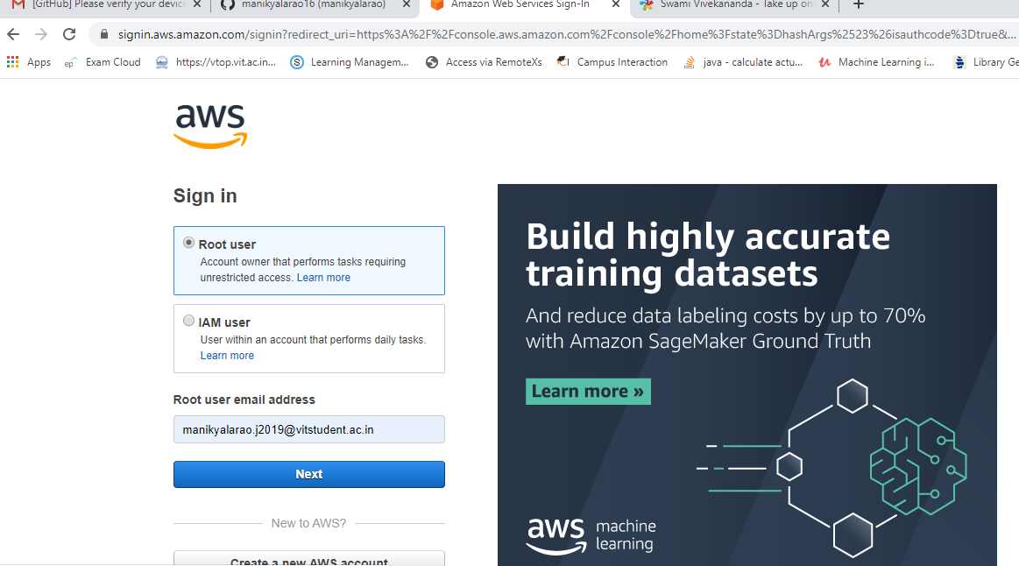

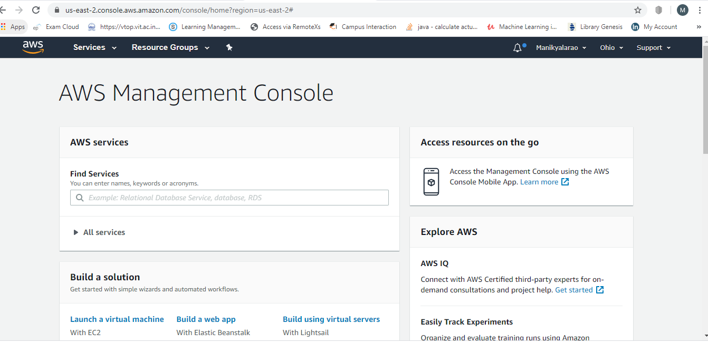

1. **EC2 Dashboard:**

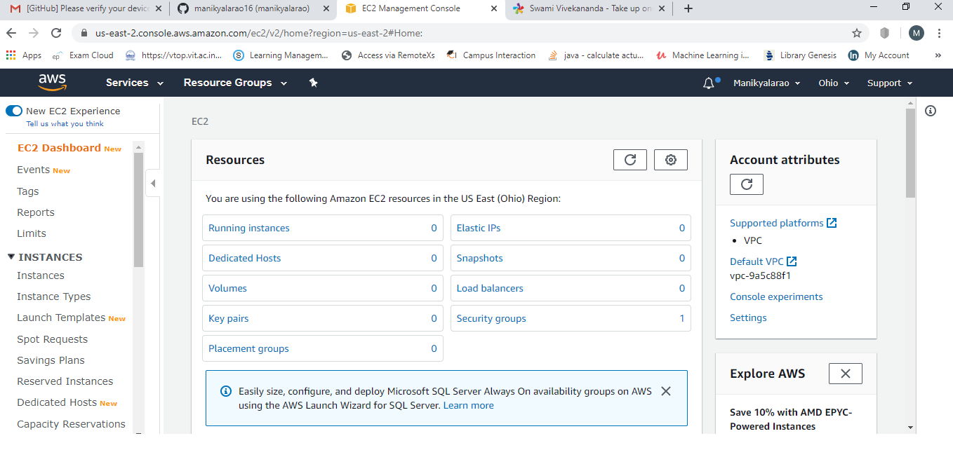

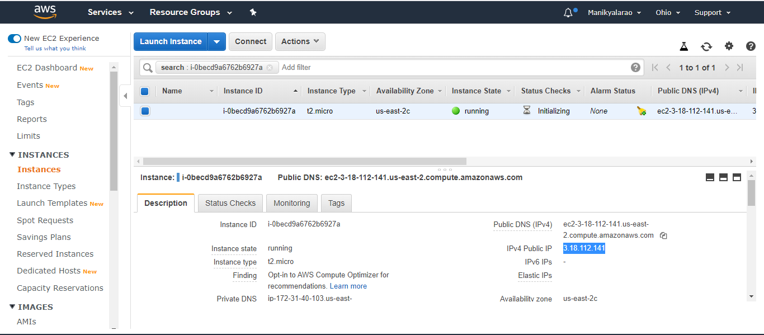

1. **S3 Dashboard:**

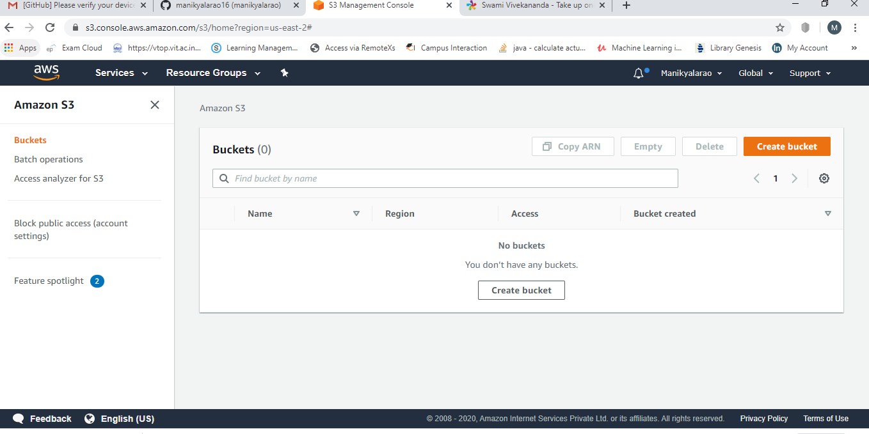

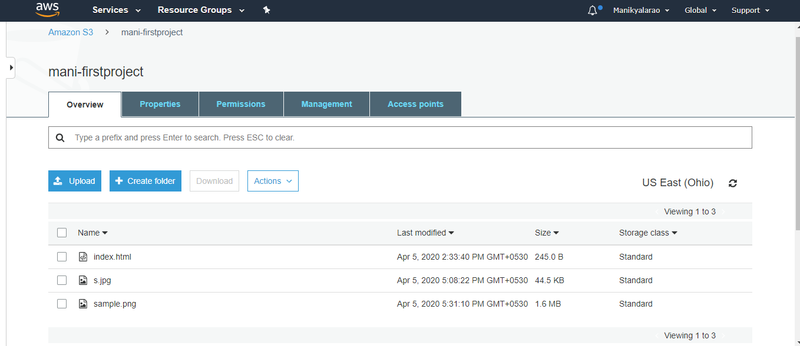

1. **Rekognition Dashboard:**

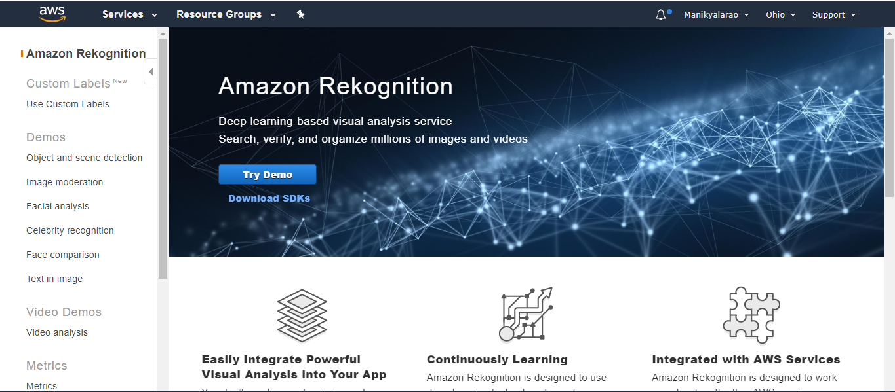

1. **EC2:**
2. **Choosing an AIM**

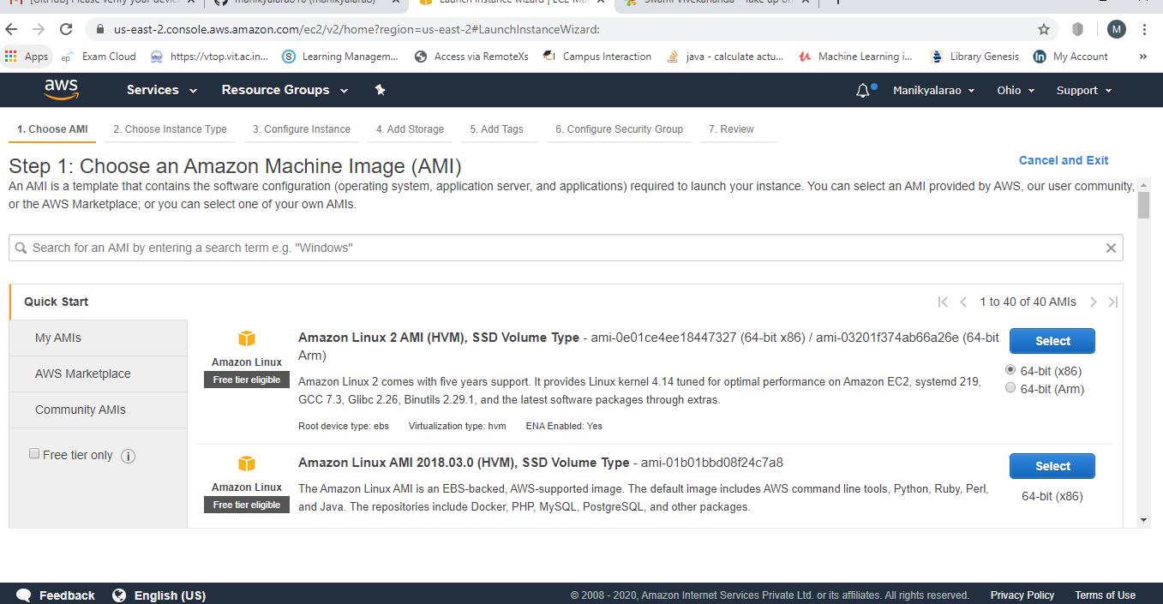

1. **Choosing an instance:**

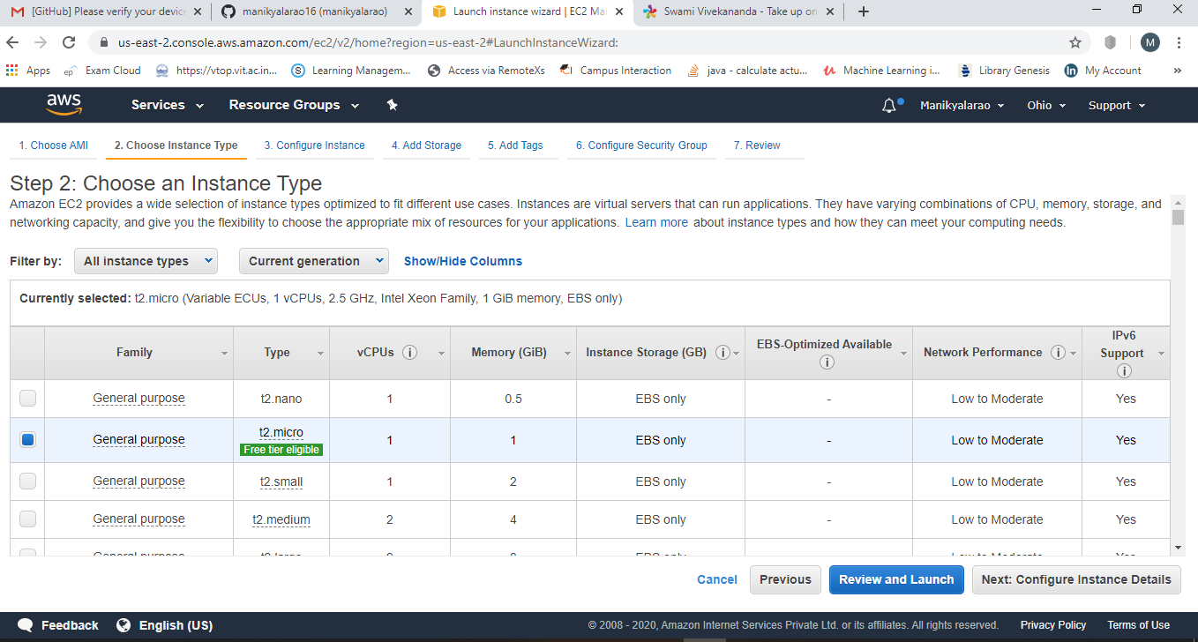

1. **Adding storage:**

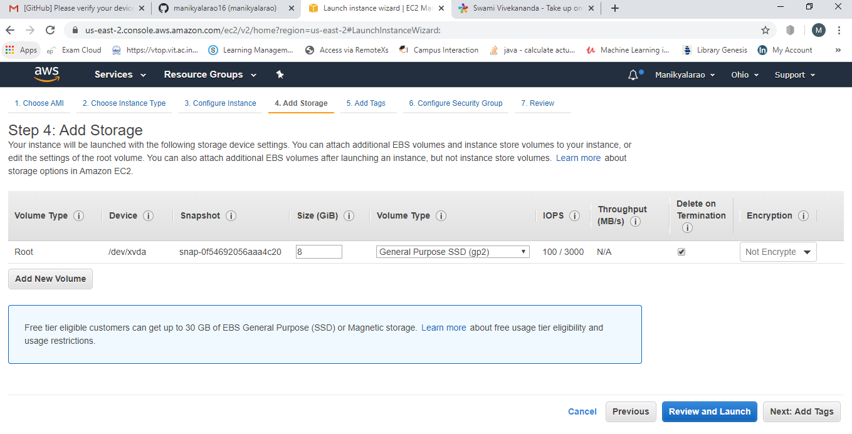

1. **Configuration Security group:**

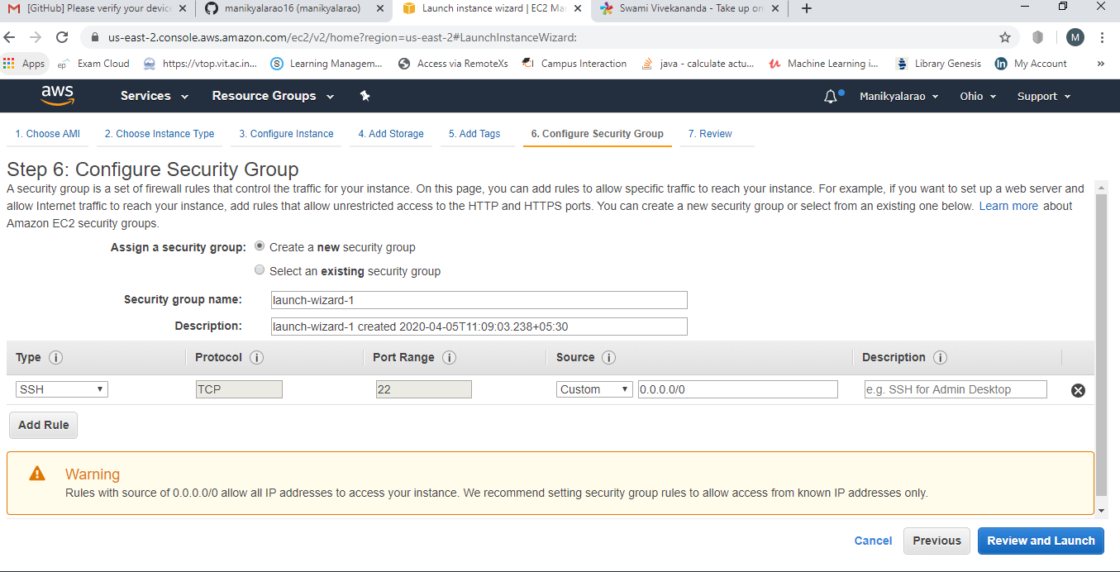

1. **Key Pair Download:**

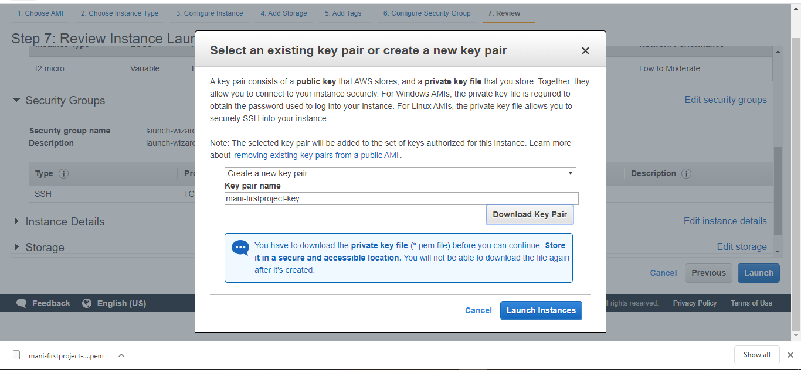

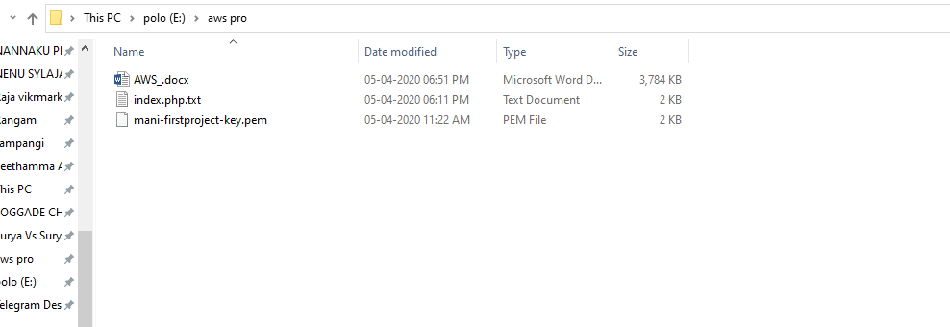

1. **Puttygen conversion from pem to ppk:**

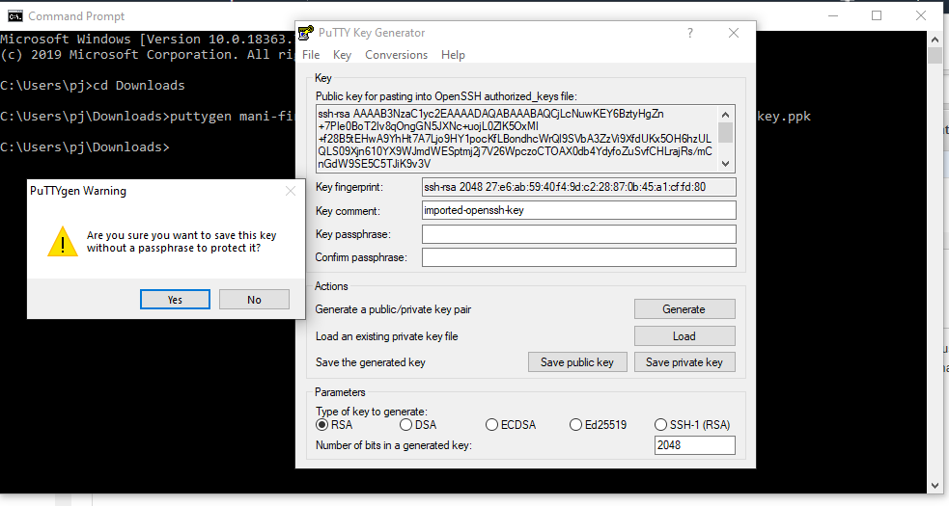

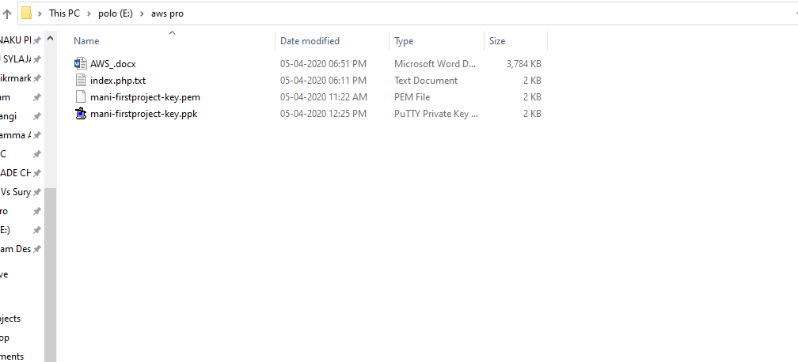

1. **Logged in EC2 black Screen:**

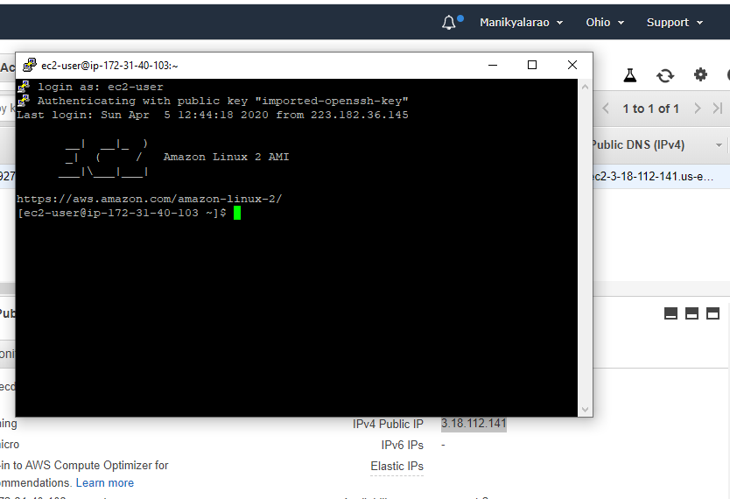

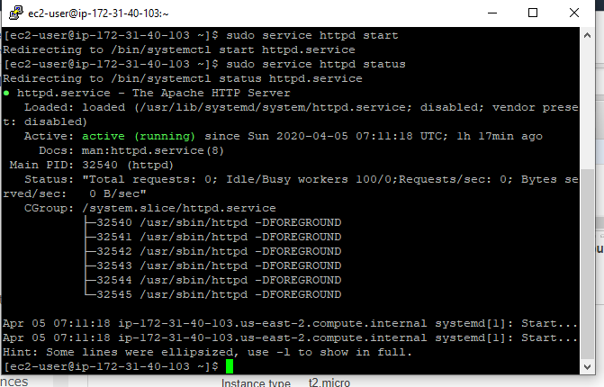

1. **S3**
2. **Creating a bucket:**

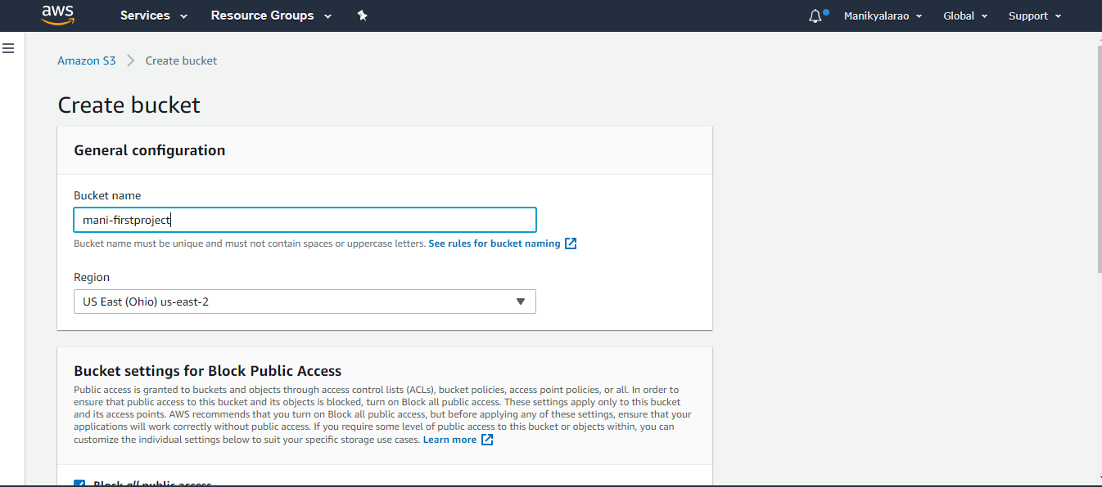

1. **Uploading an Object:**

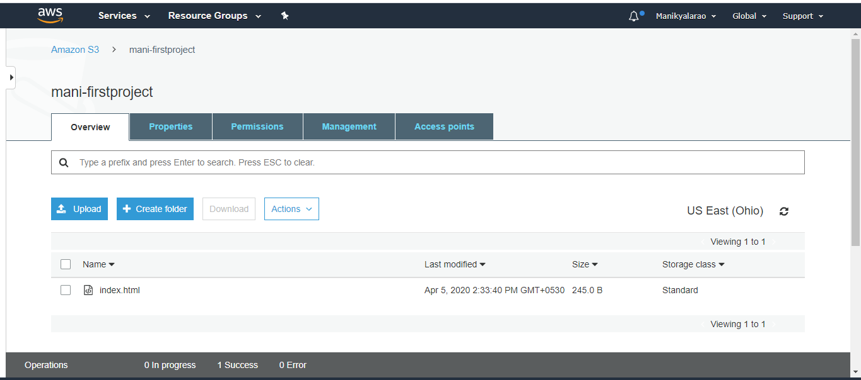

1. **Enabling static website:**

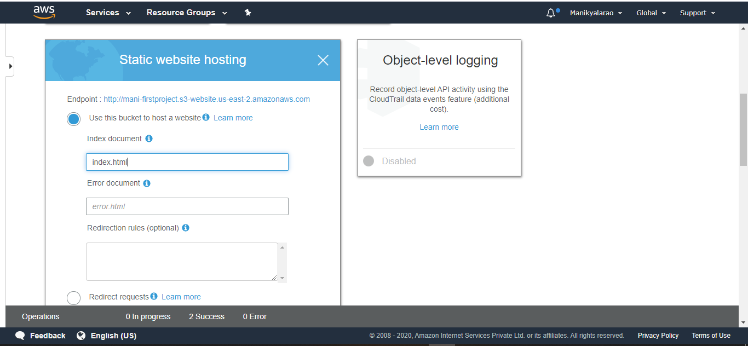

1. **Making the object public:**

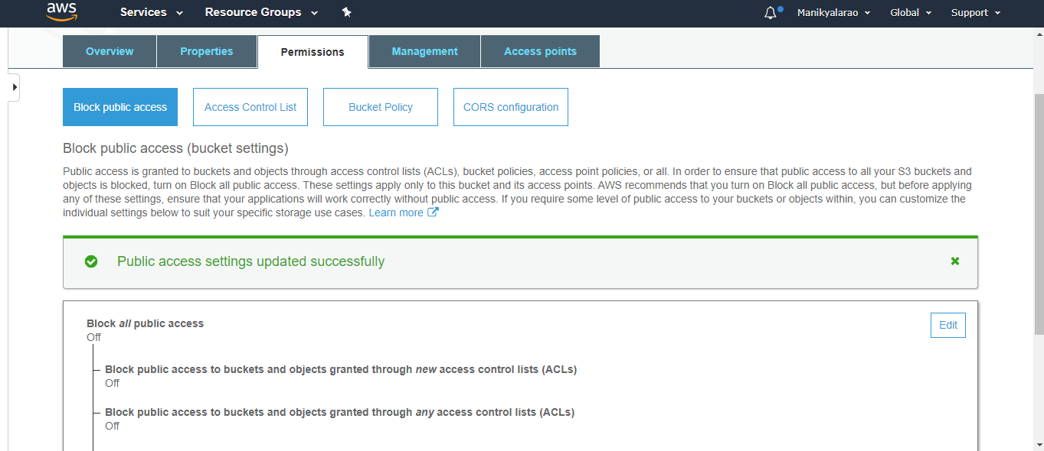

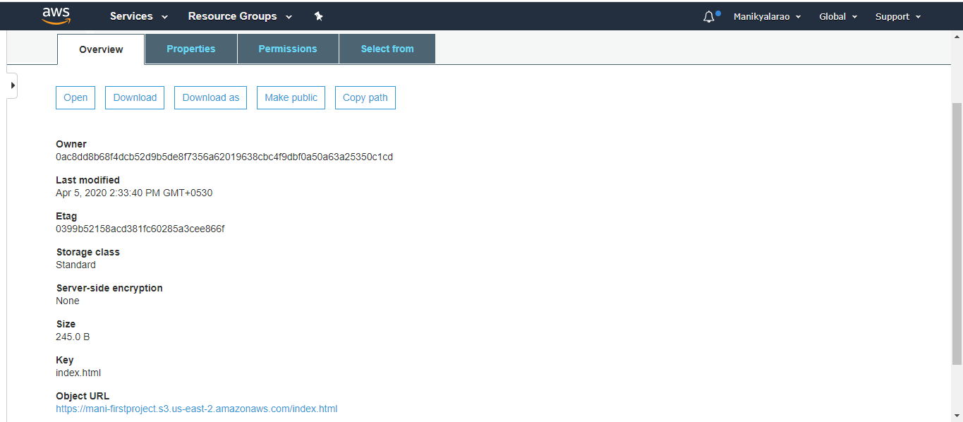

1. **Checking the S3 link on browser:**

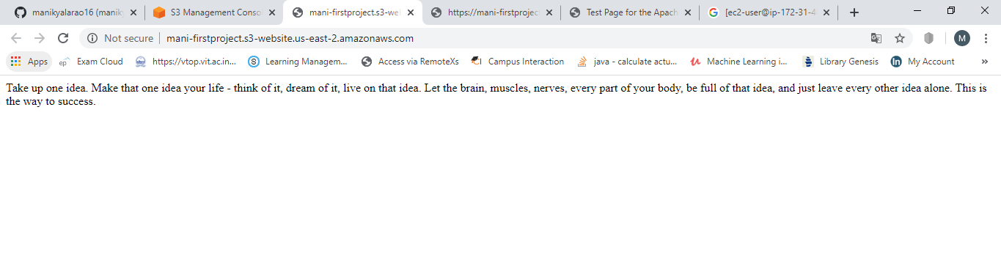

1. **Rekognition**
2. **Face detection:**

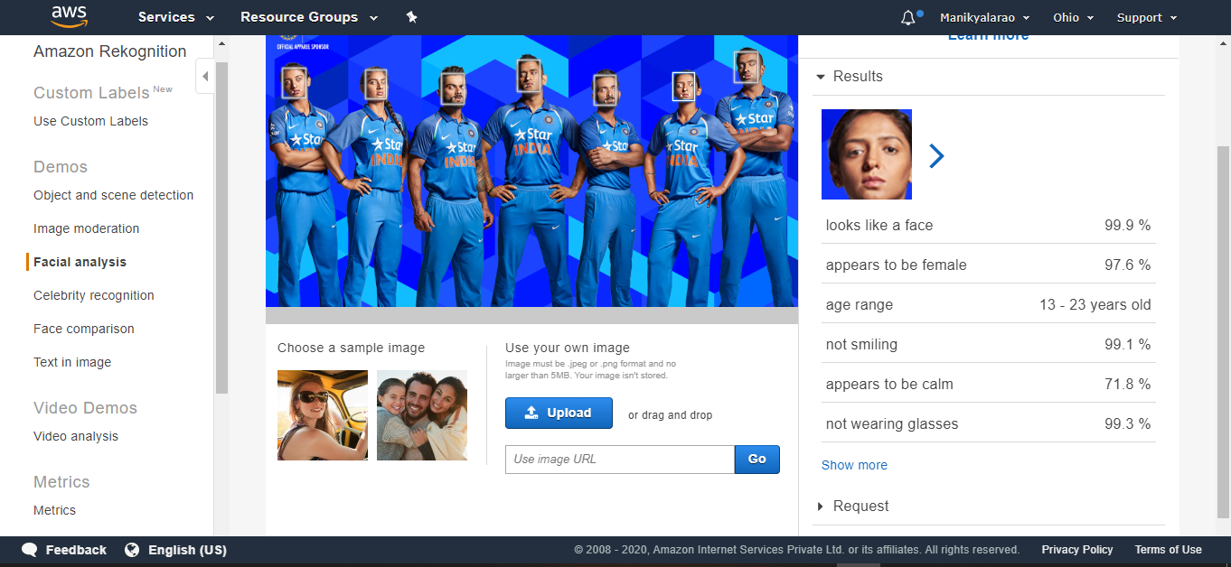

1. **Face compare:**

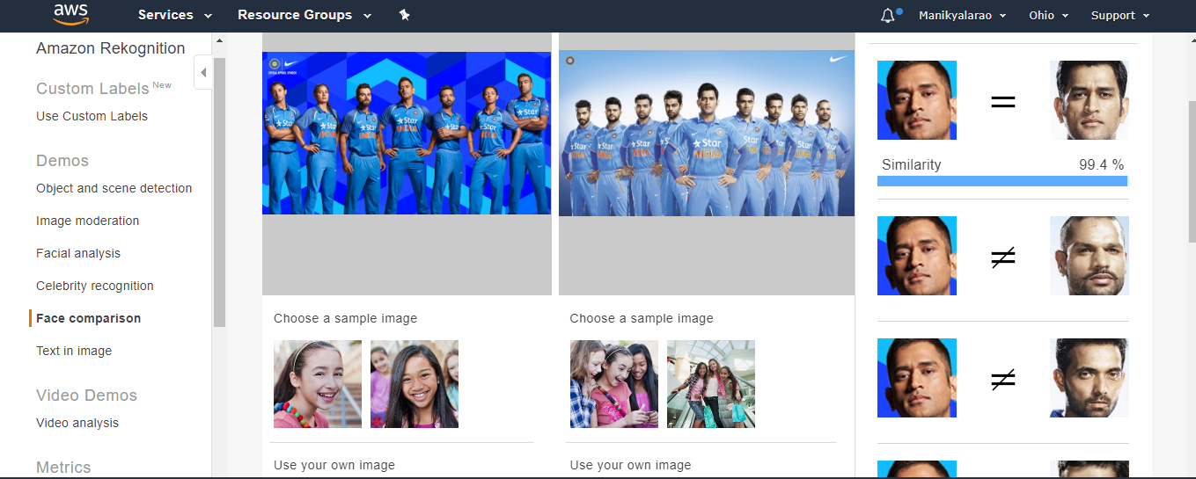

1. **Celebrity recognition:**

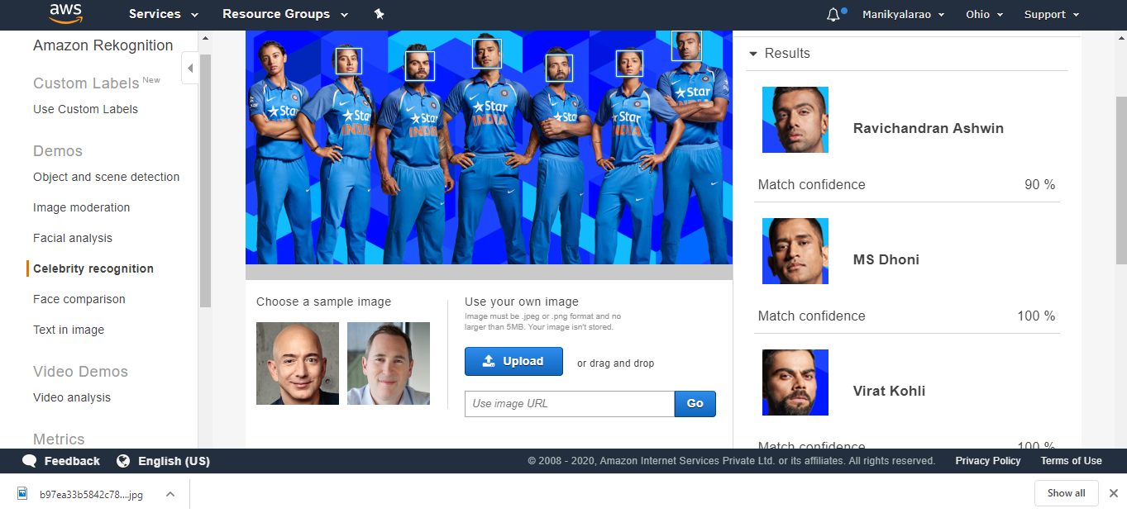

1. **Text in image:**

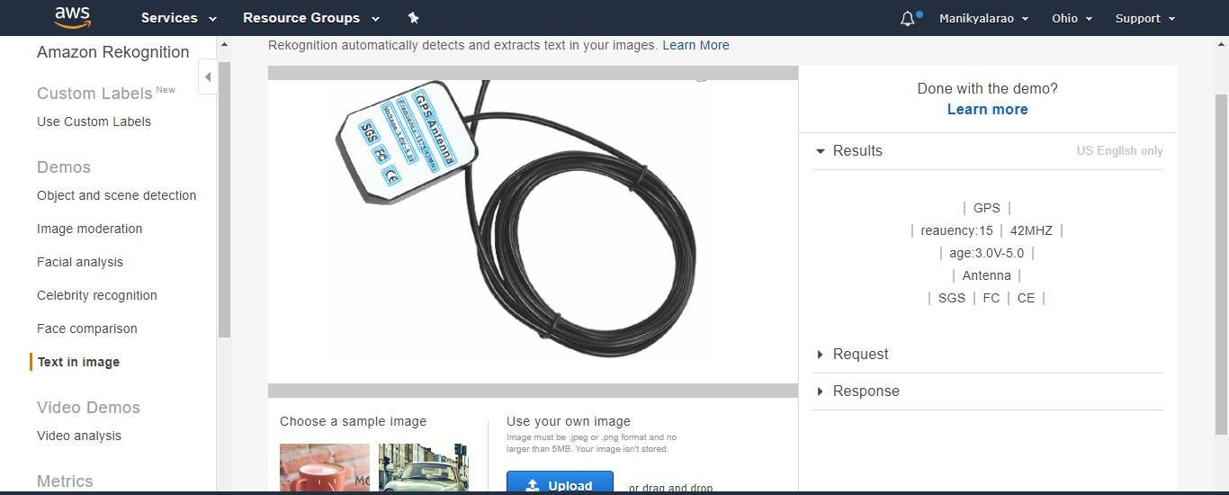

1. **EC2 and S3**
2. **Installing aws-sdk:**

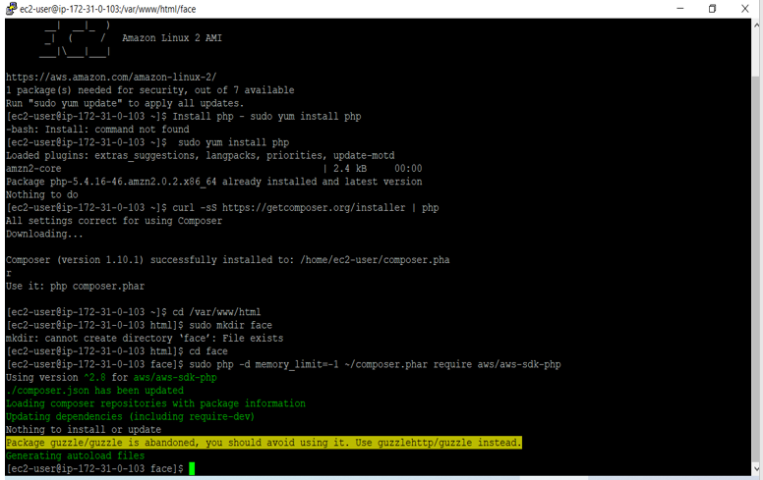

1. 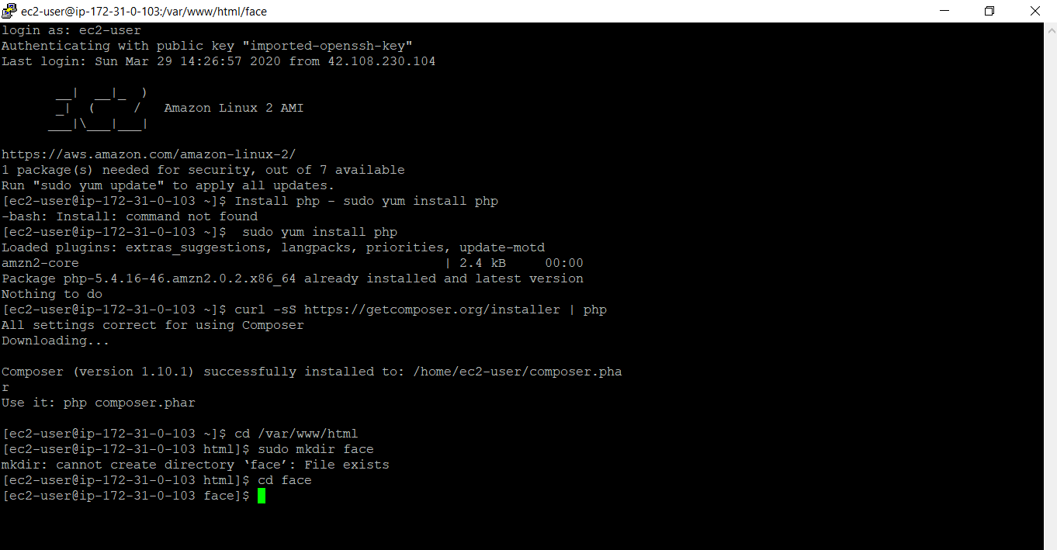**Installing php:**
2. 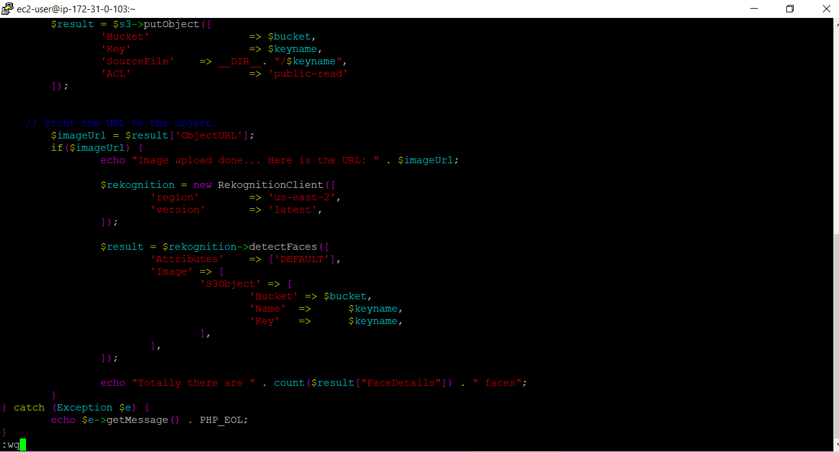**Installing-php file code:**
3. 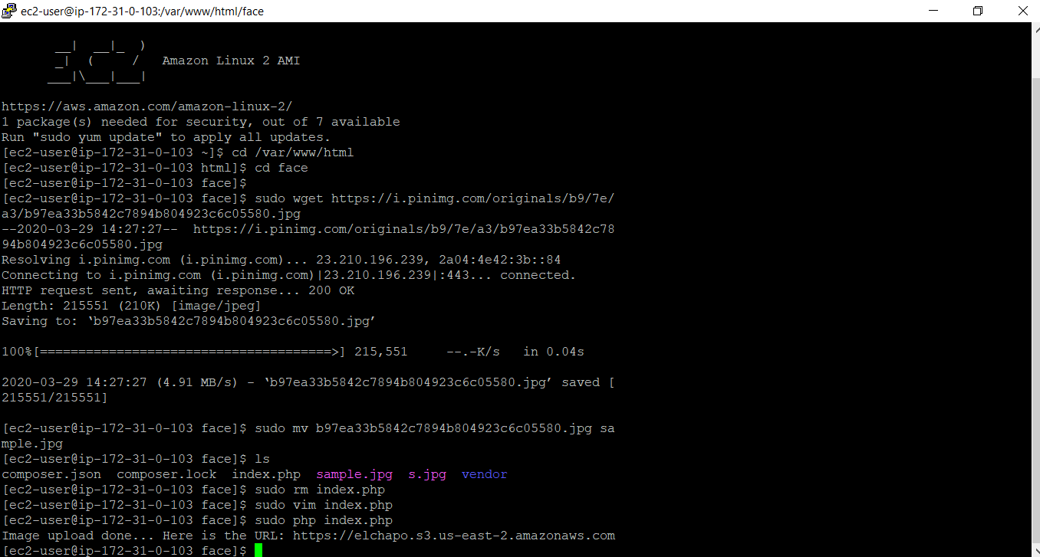**Uploading success screenshot:**
4. **EC2 & Reckognition**

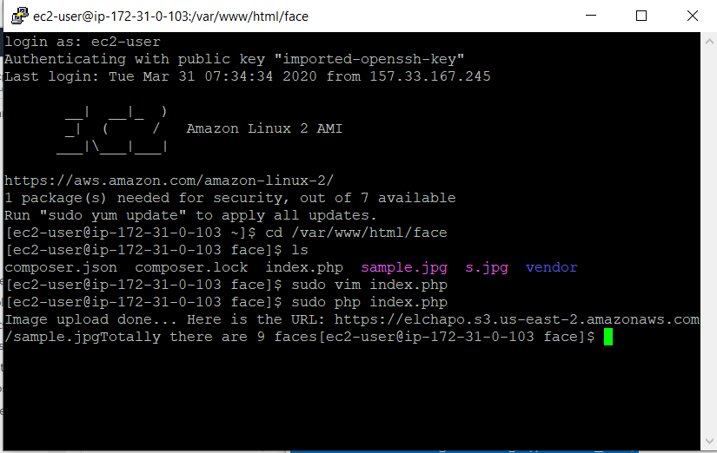**Face detect success screenshot:**